**School of Life Sciences**

**2020 – 2021**

**LIFE3081**

**Biochemistry Themed Research Project – C - 14328692**

**Employing BmrA as a paradigm to predict and identify residues implicated in multi-drug resistance by ABC transporters.**



**Supervisor: Dr I. Kerr**

**Employing BmrA as a paradigm to predict and identify residues implicated in multi-drug resistance by ABC transporters:**

**Table of Contents:**

**Covid-19 Lockdown Statement:** 2

**Abbreviations:** 3

**Acknowledgments:** 4

**Abstract:** 4

**Introduction:** 4

**The Phylogeny of MDR Pumps and ABC Transporters:** 5

**ABC Transporter Architecture:** 6

**The Switching Model of ABC Transporter Functionality:** 7

**MDR to antibiotics:** 9

**MDR to chemotherapies:** 10

**Methods:** 11

**Results and Discussion:** 11

**Selecting homology models against BmrA:** 11

**Selecting BmrA-specific substrates:** 14

**The General Structure of BmrA:** 15

**Hydrophobic substrates enter from the bilayer into a central binding cavity through interaction with *trans*-TM helices 2 and 5 at the bilayer-protein interface:** 16

**TM4 acts as a flexible gatekeeper regulating entry of transport substrates into the central cavity:** 19

**We speculate efflux of transport substrates from the central cavity proceeds through a two-step interaction involving two proximal ligand-binding sites:** 22

**References:** 28

# **Covid-19 Lockdown Statement:**

The original project proposed each student would conduct four weeks of laboratory research to determine the change in the rate of drug efflux following an individual point mutation of BmrA. Point mutants would be chosen according to observation of residues implicated in computational models of BmrA-ligand interaction, and acquired from a bank of available BmrA mutations. Data from all thirteen students would then be amalgamated to provide an overview of which helices and specifically residues from BmrA are implicated in polyspecific drug efflux. Unfortunately, the announcement of a third national lockdown prevented students from accessing laboratories, and therefore residues identified in transport substrate binding were determined using only computational models. Dr Kerr’s lab also provided experimental results for two point mutations from BmrA, investigating the change in drug efflux rates following F286A and F291A mutation with both doxorubicin and Hoechst-33342 ligands. This project, therefore, can still provide further insight into the recommended identity of point mutants in future research involving BmrA, without conducting laboratory research.

# **Abbreviations:**

ABC: ATP-binding cassette

BP1: Binding Pocket 1

BP2: Binding Pocket 2

FASTA: FAST-All

GMQE: Global Model Quality Estimation

HEPES: 4-(2-hydroxyethyl)-1-piperazineethanesulfonic acid

IF: Inward-Facing

IFC: Inward-Facing Conformation

IPTG: Isopropyl β-d-1-thiogalactopyranoside

MATE: Multidrug And Toxic Compound Extrusion

MDR: Multi-Drug Resistance

Mg: Magnesium

MFS: Major Facilitator Superfamily

NBD: Nucleotide-Binding Domain

OF: Outward-Facing

OFC: Outward-Facing Conformation

PDB: Protein Data Bank

QSQE: Quaternary Structure Quality Estimation

RNAP: RNA Polymerase

RND: Resistance-nodulation-division

SMR: Small Multidrug Resistance

TM1: Transmembrane Helix 1

TM2: Transmembrane Helix 2

TM3: Transmembrane Helix 3

TM4: Transmembrane Helix 4

TM5: Transmembrane Helix 5

TM5’: *trans*-Transmembrane Helix 5

TM6: Transmembrane Helix 6

TMD: Transmembrane Domain

UTI: Urinary Tract Infection

WT: Wild-Type

# **Acknowledgments:**

We thank Dr I. Kerr for his regular insight into the general field of ABC transporters, and for crucial input into draft dissertations. We also acknowledge Dr D. Briggs for collecting experimental data measuring the rate of both doxorubicin and Hoechst-33342 efflux from WT, F286A, F291A and E504A BmrA.

# **Abstract:**

MDR represents a stark threat to global public health. The ability of prokaryotes to simultaneously resist a broad spectrum of antibiotics can render previously treatable diseases incurable. Prognoses for cancer patients also worsen following onset of MDR, as cells become tolerant to chemotherapies. The most common mechanism for MDR development is ABC transporter overexpression. The study of these proteins underpins biological research into antitherapeutic drug efflux, and provides further insight into design of modulatory treatments for clinical use. Here, we employ SwissDock to model interactions between three conformations of BmrA, a paradigmatic ABC transporter, with four known transport substrates. Predicted high-affinity interactions are visualised using ChimeraX software, with all residues within 3.0 Å of the ligand recorded to identify those implicated in MDR.

Strongest ligand-protein affinity was observed at the TM2-TM5’ interface, corroborating existing evidence these gating helices facilitate polyspecific drug entry into the central transporter cavity. We then propose a two-step mechanism for efflux from this cavity; a 20° rotation in the regulatory TM4 gatekeeper enables TMs1 and 3 to preliminarily bind ligands, termed BP1. Transport substrates then migrate to the opposite face of TM3 to form obligate interactions with phenylalanine-291: BP2. The precise nature of BP2-ligand binding is substrate-specific; identifying residues requisite for efflux of individual drugs is an attractive research target, as modulatory drugs can be designed that retain the ability of ABC transporters to resist exogenous toxins. For example, confirming the importance of M295, a residue implicated in vinblastine efflux, may shape design of chemosensitisers that reduce the extent of resistance against this specific chemotherapy, improving patient prognoses.

# **Introduction:**

MDR refers to the ability of cells to simultaneously resist a broad spectrum of extrinsic molecules. Tolerance to antimicrobial compounds proves selectively advantageous for prokaryotes, hence the abundance of multi-drug resistant bacteria is rapidly escalating [1]. However, the increased manifestation of this phenomenon across prokaryotic populations represents a serious threat to worldwide public health, as MDR can render antibiotic therapies ineffective [1].

The antitherapeutic consequences of MDR are not limited to prokaryotes – eukaryotic cancer cells often exhibit concurrent resistance to a slew of structurally unrelated chemotherapies following exposure to one anticancer agent. As cancer cells are more prone to mutation than germ cells, primary tumours are predisposed to developing MDR, as various cell strategies that engender successful resistance from cytotoxins become more liable to malfunction [2].

The classical mechanism of MDR development is the overexpression of membrane efflux pumps. Overexpressing these protein transporters can increase efflux of therapeutic drugs out of cells, diluting their concentration and thereby reducing their efficacy. The onset of MDR is particularly associated with three members of the ABC transporter family – ABCB1, ABCC1 and ABCG2 – therefore mechanistic understanding of polyspecific drug extrusion by these pumps may expedite future aversion of undesirable therapeutic efflux [3]. Here, BmrA, an ABC exporter from *Bacillus subtilis*, is employed as a paradigm to understanding ABC transporters, as it is easily manipulable, displays strong homology with clinically relevant MDR pumps including ABCB1, and binds multiple substrates, many of which are readily detectable in laboratory assays.

Identifying residues predicted to facilitate polyspecific drug efflux will further understanding of the mechanism by which TMDs of BmrA bind an array of external ligands. However, it is important to note future treatments must retain the overall functionality of the ABC transporter, to prevent cells becoming unable to resist toxic compounds. Knowledge of substrate-specific contact residues will therefore more prominently shape development of treatments aimed at circumventing MDR, such as small-molecule chemosensitisers; these therapies can be designed specifically to bind residues that would otherwise precipitate unwanted drug efflux. Efflux-pump inhibitors such as reserpine are therefore rarely used clinically due to harmful side-effects associated with these treatments, including stomach cramps and hypotension [4]. It is also worth mention chemosensitisers can be directed to allosteric binding sites on the transporter; therapeutic strategies are not limited to the TMD.

## **The Phylogeny of MDR Pumps and ABC Transporters:**

The existence of MDR pumps in eukaryotes was only expounded in 1976 following discovery of P-glycoprotein, a member of the ABC transporter superfamily [5]. However, efflux pumps are evolutionarily ancient membrane proteins, ubiquitous across all three domains of life, and subject to a high degree of conservation at both the genetic and protein level [6]. The ability of MDR pumps to confer resistance to multiple therapeutic agents is therefore a secondary consequence of their primary function, to extrude foreign compounds from cells, rather than an independently evolved characteristic.

Bacterial efflux pumps are classified into five superfamilies: MFS, MATE, RND, SMR and ABC [7]. The first four of these families are secondary transporters, coupling drug efflux with an electrochemical potential difference to generate an energy source for active molecular translocation. Contrastingly, the remaining ABC transporter superfamily utilises ATP hydrolysis as an energy source for transportation of foreign compounds; these transporters are categorised as either importers or exporters, defined by the direction of molecular transport relative to the cytoplasm [7].

ABC transporters comprise one of the largest known protein superfamilies, with representation across all extant phyla [8]. In humans, comparative genomic sequence analysis has enabled delineation of the ABC transporter superfamily into seven subfamilies: ABCA-ABCG. ABCE and ABCF lack a TMD, and have therefore not been associated with MDR [9]. However, the remaining five subfamilies are all implicated in the onset of MDR to several therapeutic agents, and therefore represent attractive targets for our project.

## **ABC Transporter Architecture:**

ABC transporters typically comprise four core subunits: two NBDs, which bind and hydrolyse ATP, and two TMDs, which bind multiple transport substrates. Some eukaryotic ABC transporters contain all four domains in the same polypeptide, whilst other ‘half-transporters’ combine either identical, homodimeric or unique, heterodimeric halves to form a complete transporter. These dimers therefore exhibit varied degrees of symmetry; heterodimers and full-length ABC transporters possess pseudosymmetry, whereas homodimers present mirror symmetry, as transporters comprise identical halves [10].

In prokaryotes, the four domains of the ABC transporter can derive from any combination of individual, paired, or fused core subunits. BmrA consists of two homodimeric subunits; it has been suggested dimerisation proceeds following co-operative binding of two ATP molecules to the NBDs, each associated with magnesium cofactor [11]. These Mg-ATP molecules are sandwiched between the signature LSGGQ motif from one monomer, and the Walker-A motif of the second monomer, enabling the two NBDs to form a closed dimer [11].

The canonical architecture of a complete ABC transporter is represented in Figure 1, which displays the relative cytosolic positioning of each of the four core domains. The ABC superfamily displays little conservation within the TMDs, containing a variable number of constituent helices dependent on the nature of transporter [10]. However, ABC transporters commonly contain twelve membrane-spanning helices, six in each TMD [10]. Interestingly, these helices show broad substrate specificity, meaning a wide range of compounds can be translocated by an individual transporter. For example, BmrA facilitates efflux of transport substrates as diverse as doxorubicin, an anticancer agent that impedes topoisomerase-II functionality, 7-aminoactinomycin-D, an analogue of actinomycin-D antibiotic, and Hoechst-33342, a stain employed to demonstrate existence of MDR in cells [12].

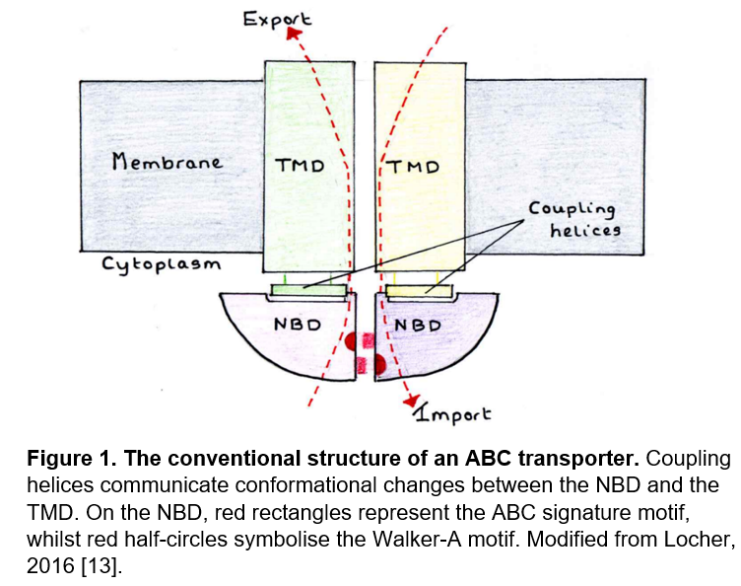

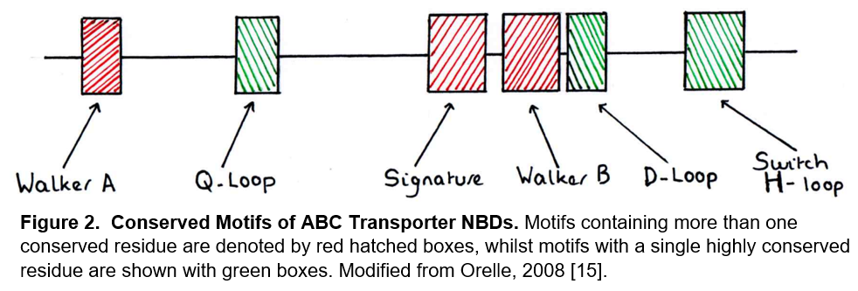Contrastingly, NBDs contain several conserved motifs homologous throughout the ABC superfamily, demonstrated in Figure 2. Walker A and B motifs, connected through a signature linker peptide, characterise these catalytic nucleotide binding sites by adopting an α-helical RecA fold, which binds ATP [10]. This signature linker peptide, with primary structure LSGGQ, shows such an extreme degree of conservation that this sequence has been used to putatively identify new members of the ABC transporter superfamily [14]. Robust conservation likely exists due to highly specific physical constraints required for ATP to bind NBDs. The oxygen atoms of β- and γ-phosphates from ATP form hydrogen bonds with a lysine residue of the Walker-A motif, whilst the same γ-phosphates coordinate both with amino groups from glycines and R-groups from serines in the linker peptide [14].

The existence of conserved sequence between NBDs extends beyond the Walker and signature LSGQQ sequences; the Q-loop contains eponymous glutamine residues essential for coupling ATP hydrolysis with transport substrate binding, whilst the H-loop comprises an essential histidine residue critical to proton transfer in the ATP catalytic-cycle [16]. This conserved H-loop resides within the switch-region of ABC transporters, crucial to associating NBDs and TMDs such that ATP can bind and compounds can translocate – a mechanism termed the switching model [16].

## **The Switching Model of ABC Transporter Functionality:**

ABC importers are basally outward-facing; the inverse is true for exporters, which move external substrates from the *cis* to the *trans*-side of the membrane, hence their TMDs are initially orientated towards the *cis*, intracellular face of the membrane. This paper focuses on an ABC exporter, BmrA, thus all following discourse relates to exporter functionality.

In their basal state, ABC exporters present an inward-facing open conformation, with high affinity for transport substrates and low NBD affinity for ATP. The switching model displayed in Figure 3 proposes a conformational switch from this basal inward-facing open conformation is triggered when a transport substrate binds a TMD, with high affinity for the external substrate [17]. This interaction enhances NBD affinity for ATP, precipitating cooperative binding of two ATP molecules to generate a closed ABC transporter dimer [17].

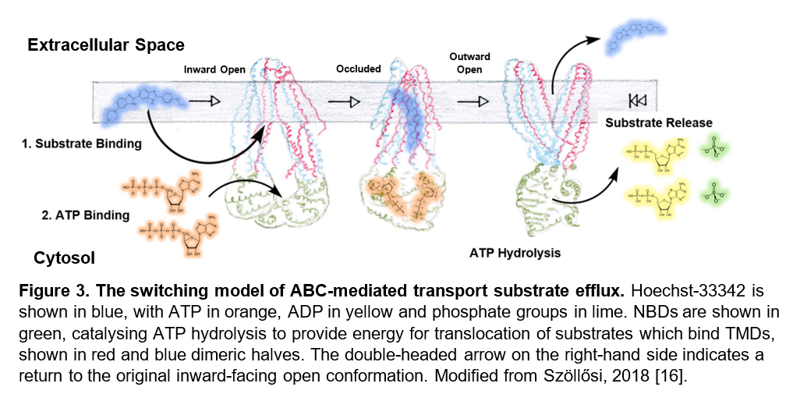When ATP is bound but not yet hydrolysed, type-I exporters such as BmrA adopt an intermediary outward-occluded state, where the two NBDs have dimerised but the central TMD cavity has not yet opened, and so the molecule is buried, closed off from both sides of the membrane [18]. To form this occluded conformation, two helices from each TMD extend and interface with their respective *trans*-NBD, with coupling transmembrane helices binding conserved NBD subdomains, particularly the signature LSGQQ motif [18]. Type-II exporters, such as ABCG2, do not exhibit this intermediary occluded conformation – close spatial proximity between type-II TMD and NBDs prevents domain-swapping between opposite halves of the transporter dimer, as *cis*-domains are too tightly coupled to allow *trans*-interaction [19].

Both types of exporter ultimately present an open outward-facing conformation where the transport substrate is exported following hydrolysis of NBD-bound ATP. This conformation has decreased affinity for the transport compound, due to concomitant stiffening of a dynamic cluster of defined residues that facilitate transport substrate efflux [12]. The TMDs of the exporter are now orientated towards the *trans*, extracellular face of the membrane, from which molecules are extruded.

It is important to note ATP hydrolysis is not essential to inducing the outward-facing conformation: as demonstrated by Lacabanne, the pre-hydrolytic occluded intermediary state displays extensive similarity to the open outward-facing conformation [12]. However, this chronological sequence of events is common when ABC exporters switch between conformations. The switching model therefore refers to the change in orientation of the TMD when NBDs bind and hydrolyse ATP, and explains the necessity for high conservation within the latter domain: non-canonical sequence will prompt less successful association between both NBD homodimers and between NBDs and TMDs, thereby perverting molecular exportation [10].

All models implicitly

agree on a tight coupling between NBDs and TMDs, with the closed

NBD dimer corresponding to the outward open TMD conformation and

the inward facing TMD conformation showing looser NBD association

All models implicitly

agree on a tight coupling between NBDs and TMDs, with the closed

NBD dimer corresponding to the outward open TMD conformation and

the inward facing TMD conformation showing looser NBD association

All models implicitly

agree on a tight coupling between NBDs and TMDs, with the closed

NBD dimer corresponding to the outward open TMD conformation and

the inward facing TMD conformation showing looser NBD association

## **MDR to antibiotics:**

Cells employ multiple strategies to engender successful resistance from the effects of cytotoxins, but these approaches can paradoxically induce opposition to various medicinal treatments, including but not limited to the excessive activity of MDR pumps and ABC transporters. An alternative example is illustrated through bacterial resistance to penicillin; synthesis of β-lactamase enzyme induces hydrolysis of antibiotic β-lactam rings, preventing the therapeutic functionality of penicillin [20]. In this manner, the requirement for cells to resist external cytotoxins opposes beneficial acquisition of therapeutic compounds.

Moreover, ABC exporters are not the only efflux pump implicated in MDR development. RND pumps, which exploit the electrochemical proton motive force supplied by pH gradients to provide energy for molecular translocation, have also been associated with MDR onset [21]. Over half of multi-drug resistant *Pseudomonas aeruginosa* hospital strains are attributed to RND-pump overexpression; the ability of bacteria to resist a wide variety of antibiotic substrates represents a stark public health concern, as previously treatable diseases may become irremediable leading to patient death [22]. All five canonical bacterial efflux pumps have been previously associated with MDR development, however overexpression of ABC transporters constitutes the most ubiquitous method of therapeutic resistance, hence this paper focuses on these transporters [7].

ABC transporters, for example, are implicated in bacterial resistance to cervimycin-C, an aromatic-polyketide antibiotic primarily employed to treat vancomycin-resistant enterococci-infections, such as UTIs [23]. In 2010, Krügel *et al.* established BmrA conferred resistance to cervimycin-C, by experimentally demonstrating BmrA-knockout *B. subtilis* mutants did not grow in the presence of this antibiotic [23]. Indeed, Krügel provided a mechanism by which constitutive cervimycin resistance could arise: a spontaneous double-mutation in the promoter region of BmrA. These two mutations co-operatively induce BmrA overexpression – as a consequence, BmrA-mediated molecular efflux increases, and MDR manifests.

Cervimycin-C is not the only antibiotic substrate transported by BmrA: in 2004, Steinfels *et al.* demonstrated BmrA-facilitated efflux of 7-aminoactinomycin-D, a fluorescent analogue of actinomycin-D antibiotic [24]. Actinomycin-D intercalates guanine-cytosine pairs at transcriptional start-sites of promoters, impeding access of RNAP and therefore preventing transcription of bacterial genes, leading to their death [25]. Actinomycin-D usage has diminished through time, due to development of several alternative antibiotics with lower toxicity [26]. However, an understanding of BmrA-mediated resistance to actinomycin-D is still important: less toxic actinomycin-D derivatives are in development, which dock BmrA in a broadly analogous manner, whilst actinomycin-D is currently also used as a chemotherapy, where circumventing MDR is equally important [26].

## **MDR to chemotherapies:**

The ability of BmrA to facilitate efflux of two structurally dissimilar antibiotics demonstrates the polyspecific nature of ABC transporters; correspondingly, ABC transport substrates also include chemotherapies. ABC transporters have therefore been implicated in the onset of MDR to chemotherapeutic drugs, for example ABCB1 upregulation is associated with resistance to doxorubicin in breast cancer [27]. Doxorubicin inhibits topoisomerase-II-mediated DNA repair, preventing replication of DNA and consequently cancer cells [28]. If overexpressed ABCB1 facilitates excessive doxorubicin efflux, topoisomerase-II functionality proceeds, and breast cancer cells grow and proliferate.

ABCB1-mediated chemotherapeutic tolerance has also been documented in renal cell carcinomas [29]. Through ABCB1 overexpression, carcinoma cells acquire pharmacoresistance to vinblastine, an alkaloid chemotherapeutic agent which prevents cell cycle progression. In 2006, Mignogna *et al.* demonstrated a statistically significant decrease in survival rates of patients with upregulated ABCB1 – ABCB1 expression is now employed to more accurately prognose patients with renal cell carcinoma, and to determine whether alternative chemotherapies to vinblastine are required for treatment [30].

The mechanism of polyspecific ABCB1-mediated efflux is still poorly understood, however scientific consensus widely supports variations of the previously explained switching model. Emerging mechanistic hypotheses include an induced-fit model, where ABCB1 undergoes a conformational change such that TMDs can participate in transport substrate binding [31]. A hydrophobic vacuum-cleaner model has also been proposed, based on the observation that the majority of ABCB1 substrates are hydrophobic [32]. As a result of this hydrophobicity, transport substrates first partition into the phospholipid bilayer, before they are recognised by the transporter and subsequently exported. These two hypotheses are not mutually exclusive: a combination of several mechanistic theories may be required to eventually yield the scientific nirvana of a unifying model of ABCB1-mediated efflux. At present, however, the molecular mechanism of ABC exportation remains an enigma - it is therefore important to study paradigmatic ABCB1 homologues, firstly to identify conserved residues implicated in polyspecific transport substrate binding, and secondly to provide further insight into a mechanism of ABC-mediated efflux, such that MDR can be circumvented by action of external therapeutic agents in the future.

ABCG2 appears an obvious paradigm to ABCB1; both transporters precipitate the onset of MDR, with both transporters facilitating efflux of a consistent set of therapeutic substrates, including doxorubicin [33]. However, the two proteins are different types of exporter, and therefore exhibit significantly different structural organisation. Type-II exporters such as ABCG2 do not present an occluded conformation, as association between *cis-*TMDs and NBDs is too close, unlike Type-I exporters including ABCB1 - a type-I exporter, therefore, is better suited as a paradigm to ABCB1 [33]. Moreover, the primary sequence of ABCB1 shows greater similarity with prokaryotic ABC transporters than eukaryotic exporters such as ABCG2 [34]. Consequently, here we employ BmrA, a prokaryotic type-I exporter, as a paradigm to predict and identify residues facilitating polyspecific ABC transporter-mediated efflux. Determining the identity and nature of implicated residues is the primary objective of this project, because an understanding of transport substrate binding and extrusion by BmrA will aid design of future therapeutic agents that circumvent MDR.

# **Methods:**

The FASTA sequence of BmrA was obtained from UNIPROT under the code O06967, and entered into the SwissModel webserver to generate templates similar to this target sequence [35,36]. Target-template sequence alignment is automatically conducted by SwissModel to prevent unmatched residues with no corresponding sequence. Structural models were selected favouring several characteristics, including but not limited to strong primary sequence identity with BmrA, the estimated accuracy of the predicted structure, represented by GMQE and QSQE scores approaching one, and high structural resolution. The BmrA crystallographic structure (PDB-ID: 6r72) was chosen as our outward-facing conformation model, whilst inward-facing ABCB1 and occluded TmrAB structures (PDB-IDs: 4q9j and 6rai respectively) represent our two homology models against BmrA [37].

We then employed SwissDock to predict docking interactions between these three structural models of our BmrA target with four transport substrates – doxorubicin, Hoechst-33342, actinomycin-D, and vinblastine [38]. Structural files for doxorubicin and vinblastine were obtained from ZINC15, a curated database of ligand structures containing stereochemical information including atomic partial-charges, under codes 3918087 and 85432544 respectively [39]. Coordinates for Hoechst-33342 (ID:130D) and actinomycin-D (ID:1A72) were extracted from existing ligand-protein structures within the PDB [37]. SwissDock is unable to compute docking of ligands onto target proteins exceeding 15,000 atoms, hence residues 460-589 were removed from all homology models, whilst ligand flexibility was restricted to improve docking performance. Following successful docking performed with high stringency, the fifteen clusters with strongest predicted binding affinities for selected ligands, and hence most negative Delta-G values, were visualised using ChimeraX software, with all residues within 3.0 Å of the ligand recorded on Excel [40]. We therefore compiled a set of residues implicated in transport substrate binding, from which structural patterns can be analysed to provide further insight into polyspecific ABC-mediated efflux.

# **Results and Discussion:**

To achieve our experimental aims of predicting and identifying residues associated with BmrA-mediated MDR, we investigate docking interactions between four known transport substrates – doxorubicin, Hoechst-33342, actinomycin-D and vinblastine – with three main conformations involved in the switching model of ABC efflux. Accurate, high-resolution crystal structures for complex eukaryotic ABC transporters are rare, as the complexities of capturing protein-ligand complexes produce prohibitively low resolutions that hinder mechanistic explanation for MDR onset [10]. We therefore employ a computational approach, generating homology models against BmrA into which selected transport substrates are docked to identify residues implicated in polyspecific efflux. Here, the prokaryotic exporter BmrA is utilised as a paradigm because this efflux pump displays extensive homology to a wealth of clinically relevant transporters within the ABCB subfamily, including both ABCB1 and ABCB6 [16].

## **Selecting homology models against BmrA:**

In 2021, Chaptal *et al.* elucidated the X-ray crystal structure for the OFC of BmrA, which can be employed as an accurate model for identifying residues interacting with transport substrates as they are extruded into the extracellular space [41]. However, crystal structures for both the occluded and inward-facing conformations of BmrA are yet to be determined, necessitating generation of a homology model against these conformations of efflux pump. We therefore employ crystal structures of inward-facing ABCB1 and outward-occluded TmrAB to model ligand interactions with these conformations; the Venn diagram shown in Figure 4 displays both the advantages and limitations associated with these models [42,43].

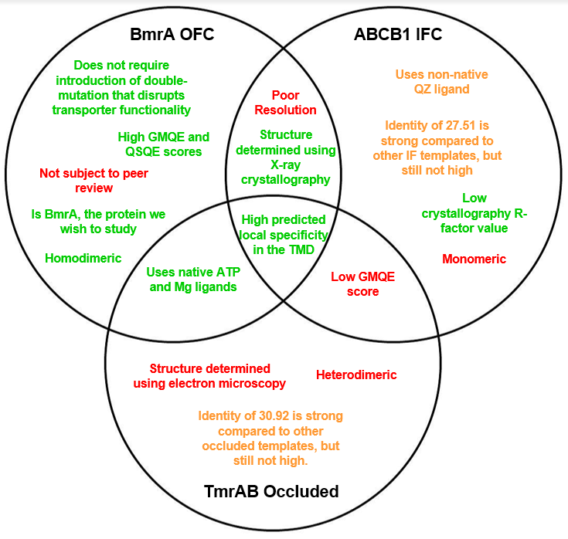

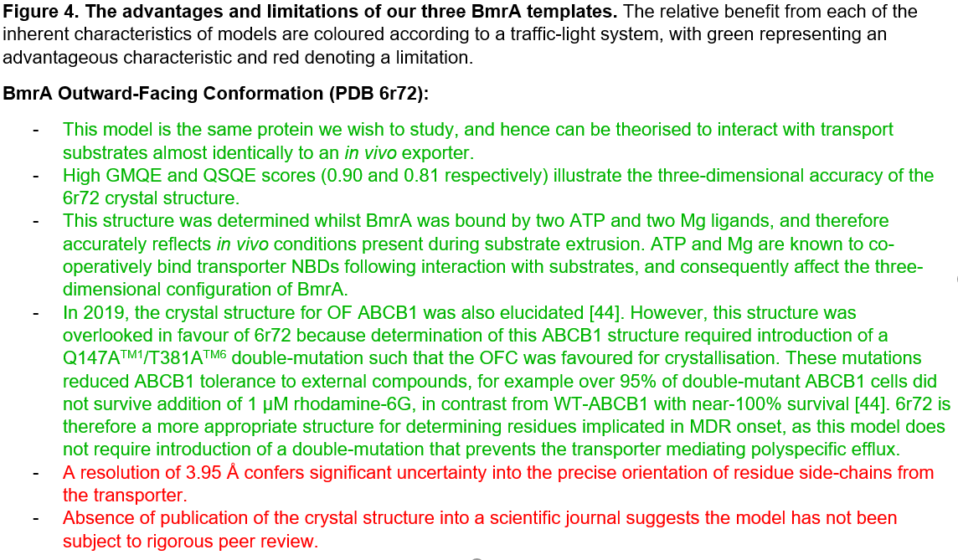

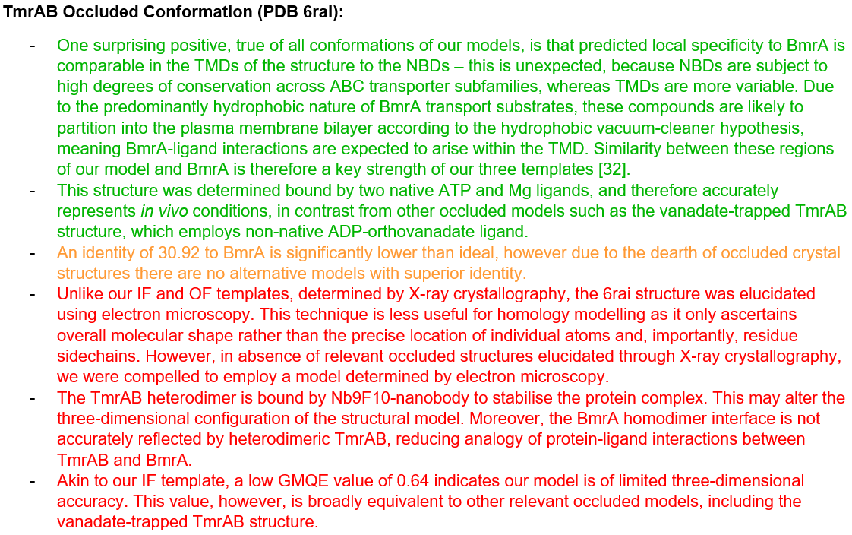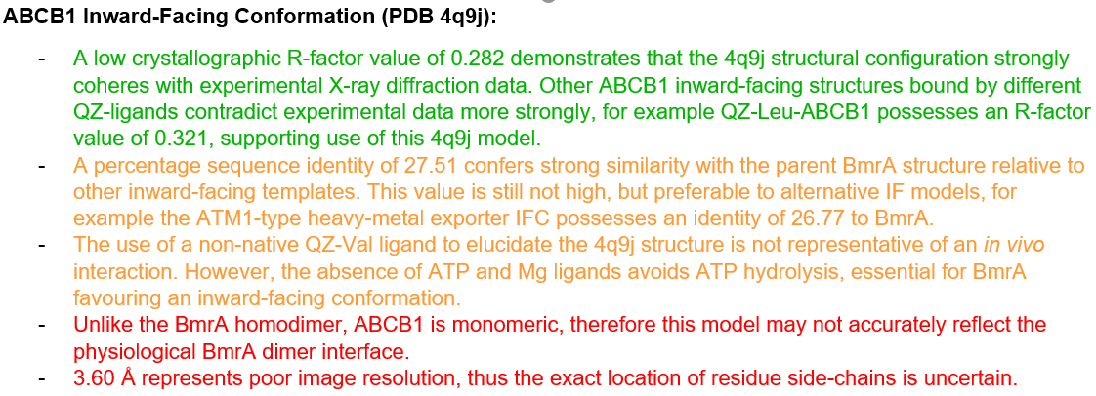

## **Selecting BmrA-specific substrates:**

Once our homology models have been chosen, relevant and specific BmrA transport substrates must also be selected to identify conserved ligand-protein contact residues. Both doxorubicin and vinblastine chemotherapies have been evidenced as specific substrates of BmrA, and are therefore attractive, appropriate ligands for elucidating a mechanism of ABC transporter efflux [12]. Another well-characterised BmrA substrate is Hoechst-33342, a blue-emitting fluorescent compound often used to stain DNA [12]. Hoechst-33342 does not fluoresce in aqueous media, hence MDR-induced extrusion of the compound causes a decrease in fluorescence intensity. Hoechst-33342 is therefore an attractive substrate to our research, as effects from future point mutageneses of Hoechst-BmrA contact residues can be easily quantified spectrophotometrically [12].

Identifying an appropriate antibiotic to dock BmrA proved challenging. BmrA has well-evidenced specificity to cervimycin-C, however we were unable to deploy this antibiotic in absence of a compatible ligand structure file for SwissDock [23]. Although ofloxacin antibiotic has been proposed as a BmrA substrate by Ruiz, this is contradicted by BmrA-knockout mutants not exhibiting reduced resistance to ofloxacin [46,47]. We therefore decided against docking ofloxacin, instead employing actinomycin-D antibiotic, which, although rarely used clinically, is a well-characteristic substrate of BmrA. Moreover, with less toxic actinomycin-D derivatives in development, the clinical relevance of this compound is only likely to increase in the future, particularly considering its additional use as a chemotherapy [26]. We therefore employ actinomycin-D as our final model transport substrate to investigate interactions between BmrA and various relevant external compounds.

We chose SwissDock to predict plausible binding sites between selected ligands and our templates, which are visualised in ChimeraX to establish the three-dimensional nature of the protein-ligand interaction [38,40]. SwissDock predicts ligand-binding sites that cohere with experimental data more reliably than other docking software, particularly when investigating molecules with less than ten rotatable bonds, such as our four selected substrates [38]. Whilst SwissDock restricts the maximum number of atoms in target proteins to 15,000, enforcing truncation of our structural models, the improved predictive performance with small ligands relative to alternative programs including Glide and AutoDock-Vina outweighs the negative consequences of model truncation. SwissDock also quantitatively estimates binding affinity between each cluster of transporter residues and selected ligands with higher accuracy than both ROSIE and AutoDock-Vina software, further justifying our selection of SwissDock [48]. However, it is important to note predicted Delta-G values are inherently uncertain even with SwissDock, and often excessively negative for larger ligands such as actinomycin-D [49]. Whilst these values almost never equate with experimentally determined binding affinities, they provide insight into the preferred binding sites of specific ligands, and therefore further our aim of identifying residues responsible for MDR.

## 

## **The General Structure of BmrA:**

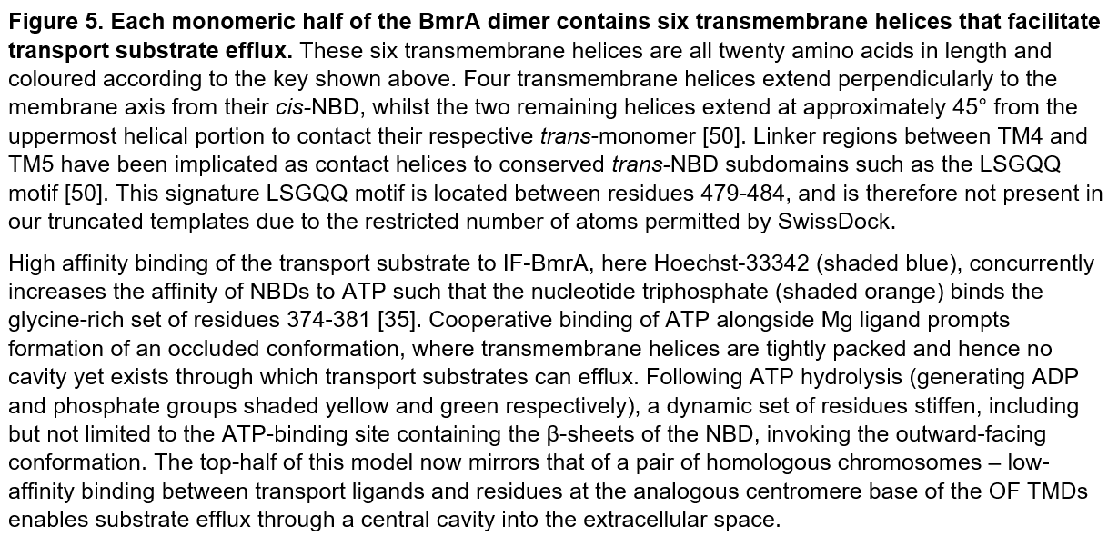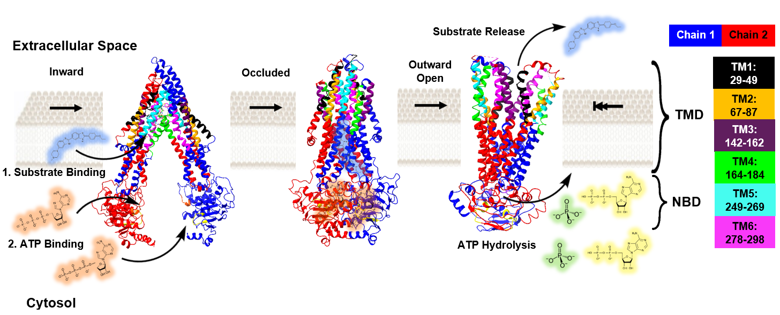The 589-amino-acid BmrA homodimer adopts classical ABC transporter architecture: two NBDs and two TMDs, with each TMD comprising six transmembrane helices. Figure 5 presents an adapted version of the switching model for BmrA, incorporating our homology templates into the schematic first introduced in Figure 3. Locations of the six transmembrane helices are represented according to the key shown in the Figure.

## **Hydrophobic BmrA substrates enter from the lipid bilayer into a central polyspecific binding cavity through interaction with *trans*-TM helices 2 and 5 at the phospholipid bilayer-protein interface:**

Due to the restricted diameter of the central transporter cavity for inward-facing conformations of BmrA, transport substrates cannot pass directly from the extracellular space into binding pockets of the cavity. Transport ligands must first partition into the phospholipid bilayer, according to the hydrophobic vacuum-cleaner hypothesis, before the exporter extracts the substrate from the bilayer into a central binding funnel [32]. This mechanism of substrate entry is consistent with the nature of characterised BmrA substrates, which are typically hydrophobic and can be very large [12]. This hypothesis also indicates that removing the C-terminal half of cytosolic NBDs from our models to satisfy the atom number constraints of SwissDock is unlikely to affect polyspecific ligand binding.

During our computational analysis, shown in its entirety in Appendix 1, strong ligand-protein affinity was consistently observed at the TM2-TM5’ interface for IFCs of BmrA. Table 1 displays the incidence of each contact residue from both TM2 and TM5 within the fifteen IF clusters estimated to bind our four model ligands with highest affinity. All four transport substrates exhibit at least two high-affinity residue clusters from the TM2-TM5’ interface; TM2 and TM5 are therefore highly implicated in facilitating polyspecific drug efflux. This TM2-TM5’ interface, and respective *trans*-equivalent, comprises the closest helices to the phospholipid bilayer for both ABCB1 and BmrA. Existing literature demonstrates the interface between the two outermost membrane-exposed helices of ABC transporters often acts as a gateway for drug entry into the central cavity [51]. In 2014, Kodan demonstrated these TM2/TM5 exterior helices present close spatial proximity in ABCB1, validating the TM2-TM5’ interface as a potential gating mechanism for drug entry [52]. Our results therefore further support this TM2-TM5’ gateway as a method for polyspecific transport substrate entry into the central cavity; we demonstrate residues from these outermost helices are highly implicated in ligand binding, and offer attractive mutagenesis sites to further understand the onset of MDR.

Figure 6 shows a stretch of contact residues along one face of both TM2 and TM5’ helices are involved in IF-BmrA binding Hoechst-33342. The high-affinity TM2 cluster exhibited here in Figure 6 is consistently observed in interactions with all selected substrates, implicating these residues as responsible for the broad specificity of BmrA. Contact residues from TM2 correspond to canonical periodic α-helical positions of i, i+4, i+7 and i+11, with small, non-polar and hydrophobic alanine amino acids located at residues 71, 78 and 82. These alanines are intercalated first with an aromatic phenylalanine residue at position 75, and secondly by hydrophilic polar-uncharged serine-81 and threonine-85 amino acids.

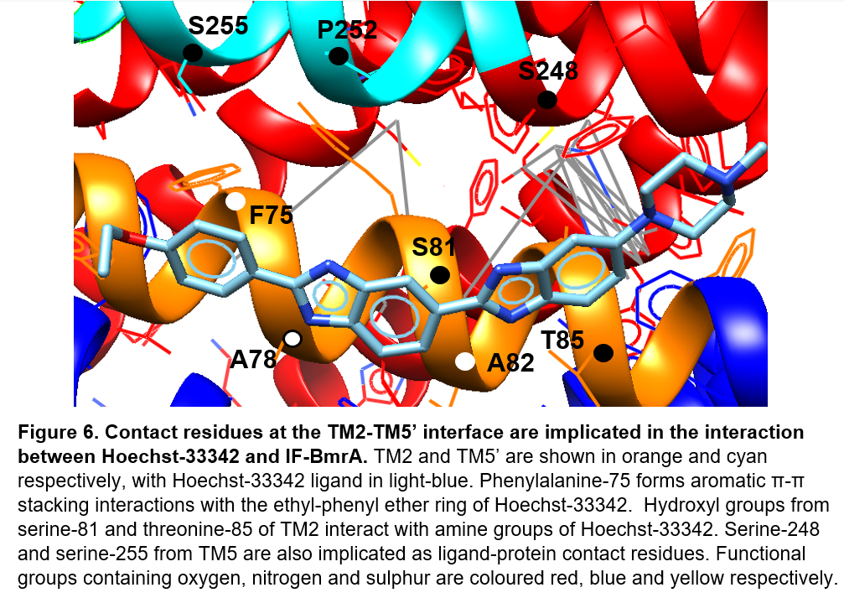

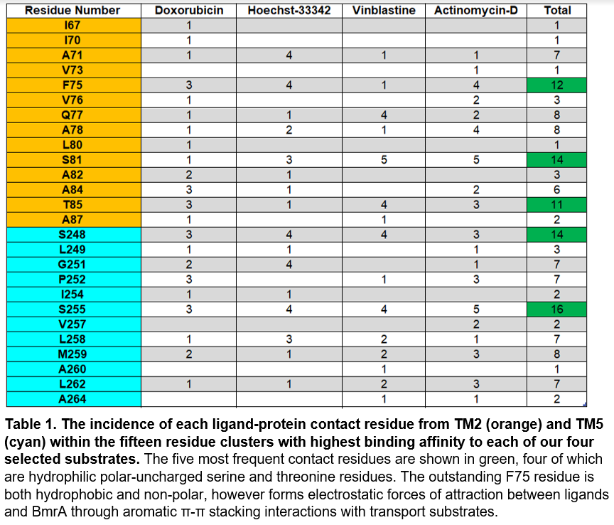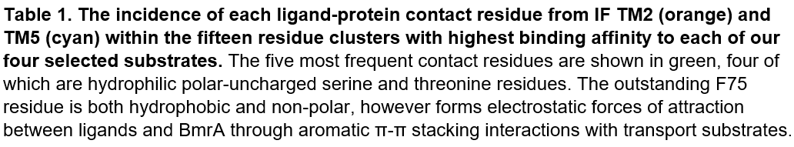

The aqueous nature of both the extracellular space and the cytosol provides an attractive environment for hydrophilicity, hence it is surprising to observe serine and threonine residues at the phospholipid bilayer-BmrA interface. Serine-threonine phosphorylation is associated with activation of many proteins, however bacterial ABC transporters are activated by two-component histidine kinase-systems [53]. Serine-81 and threonine-85 are therefore more likely to play a functional role in transport substrate binding; in 2000, Ballesteros *et al.* demonstrated the presence of serine and threonine within transmembrane α-helices creates a slight opening of the helical turn preceding the serine/threonine residue, due to repulsive forces between the sidechain hydroxyl and terminal carbonyl group [54]. Preceding TM2 contact residues such as alanine-71 and phenylalanine-75 are therefore more accessible for binding a broad spectrum of transport substrates.

Moreover, in Figure 6 we observe hydroxyl groups from serine-81 and threonine-85 residues are proximal to amine groups of Hoechst-33342. Slightly positively-charged hydrogen atoms from Hoechst-33342 amine groups may mediate hydrogen bond formation with the slight negative charge of oxygen from the serine/threonine hydroxyl side-chain. Further validatory crystallographic studies into this potential mechanism of ligand-protein interaction are required, however this hypothesis is supported by previous evidence that serine and threonine residues increase the bend angle of the helix such that these residues themselves are more open to binding an array of polyspecific ligands [54,55]. Serine-81 and threonine-85 are therefore strongly implicated in the onset of MDR for BmrA, and future point mutagenesis of these residues, through substitution for amino acids of lower hydrophilicity, will provide further insight into a mechanism of polyspecific drug efflux.

The heightened accessibility of this face of the TM2 helix also implicates other residues in the amino acid cluster as essential for ligand-protein interaction. Figure 6 demonstrates that whilst A71, A78 and A82 are more likely to be involved in α-helix stabilisation than transport substrate binding, phenylalanine-75 can form π-π stacking interactions with aromatic rings of our chosen substrates. Figure 6 shows phenylalanine-75 interfaces with the ethyl-phenyl ether ring of Hoechst-33342, conferring electrostatic forces of attraction between substrate and transporter. Determining the change in rate of drug efflux following point mutagenesis of phenyalanine-75 into an aliphatic residue of similar size and hydrophobicity, for example leucine, would therefore provide further insight into the importance of aromatic stacking interactions to polyspecific transport substrate binding of TM2.

Both Table 1 and Figure 6 reveal similarities in the nature of TM2 and TM5’ contact residues – the implicated face of the TM5’ helix also contains two serines, S248 and S255, intercalated by small, non-polar hydrophobic residues, in this case leucine. The high incidence of serine-248 as a contact residue, currently defined outside of TM5, suggests transmembrane helices of the TMDs require redefinition from the existing arbitrary constraint of precisely twenty amino-acids per-helix [35]. Both serine-248 and serine-255 therefore represent additional targets for point mutagenesis experiments with non-polar hydrophobic substitutes - these residues are implicated in binding a slew of structurally dissimilar transport substrates, and thus contribute to MDR by mediating the ultimate entry of a wealth of polyspecific compounds into the central binding cavity of the transporter.

## 

## **TM4 acts as a flexible gatekeeper regulating entry of transport substrates into the central cavity:**

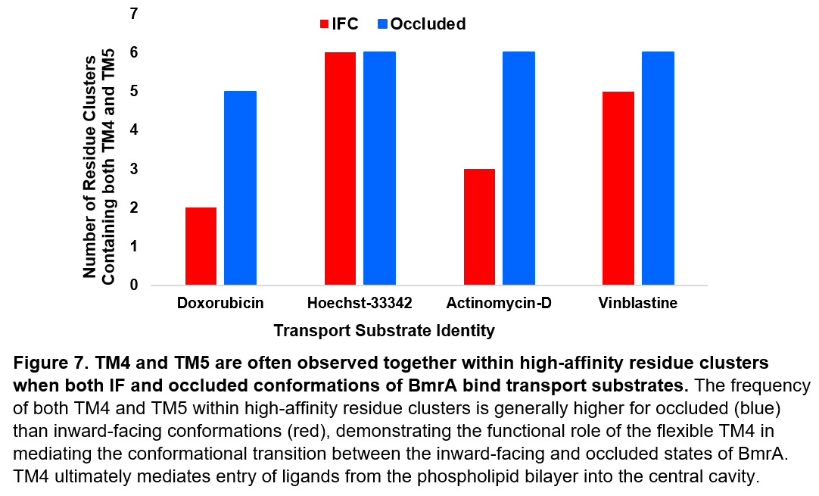Before BmrA is bound by a transport substrate, the width of the cleft between TM4 and TM6 is insufficient to allow ligand entry into the central cavity. Transport substrates must first bind BmrA to invoke a conformational change in the exporter such that molecules can enter central binding pockets. As displayed in Figure 7, residue clusters with high estimated binding affinity for transport substrates frequently contain TM4 alongside TM5 from the TM2-TM5’ interface. This TM4-TM5 association is observed most consistently within predicted ligand-binding sites for occluded structural models, but is also common within IF residue clusters. TM4 is therefore implicated in inducing the conformational switch between inward-facing and occluded states of BmrA.

Existing research has previously established that the inward-to-occluded conformational transition in BmrA is facilitated by the close association between TM4 and the TM2-TM5’ interface when binding transport substrates [50]. An array of structurally dissimilar ligands, including large compounds such as actinomycin-D shown in Figure 8, can form non-specific hydrophobic forces of attraction with one face of TM4. Interaction of the TM4 helix with these external transport substrates widens the tilt angle between NBDs such that their accessibility for ATP is increased [50]. The enhanced NBD affinity for ATP allows the two NBDs to form a closed ATP-sandwich dimer that pivots TM4, and consequently the accompanied TM2-TM5’ interface, approximately 20°, as determined by Ward in 2007. In this manner, the transport substrate becomes orientated towards the central binding cavity of the transporter, from which molecules are extruded [50]. We therefore propose that whilst the TM2-TM5’ interface is responsible for extracting a wealth of hydrophobic ligands from the phospholipid bilayer, the TM4 helix regulates the subsequent entry of these transport substrates into the central binding pocket(s) of BmrA.

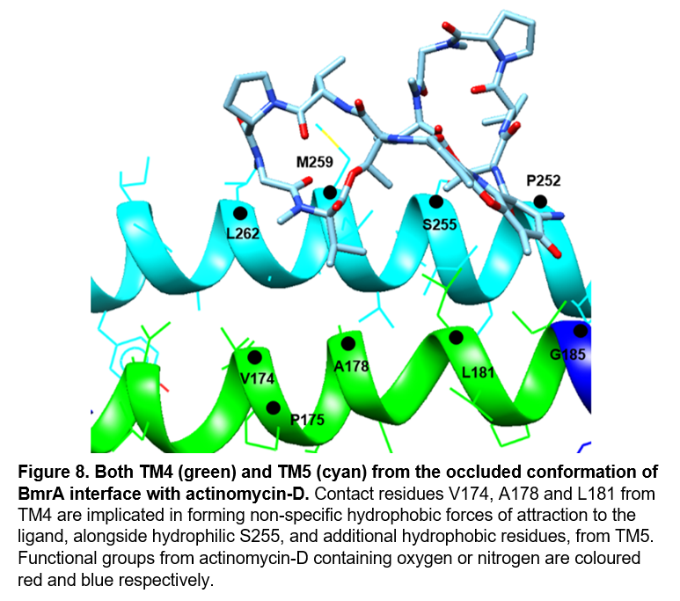The flexibility of TM4 is therefore essential to polyspecific drug extrusion; in 2014, Kodan *et al.* demonstrated that a TM4 triple-mutation replacing glycine and two alanine residues with larger side-chain substitutes significantly decreased efflux of transport substrates from ABCB1, as the larger R-groups from replacement residues reduced the flexibility of the TM4 helix [52]. Correspondingly, substitutive point mutations into larger, less-flexible replacements of the small, non-polar hydrophobic residues associated with binding actinomycin-D in Figure 8, including alanine-178, leucine-181 and glycine-185, are likely to reduce the structural plasticity of TM4. Obstructing the 20° rotation of TM4 following ligand binding will preclude BmrA from reaching the occluded stage of the switching model, impeding migration of compounds into the central cavity and ultimately preventing transport substrate efflux. It would therefore be strategic to conduct future point mutageneses of these small, non-polar hydrophobic residues from TM4, which are implicated both in forming non-specific ligand-protein forces of attraction and in maintaining helical flexibility, to further uncover their importance to transport substrate extrusion.

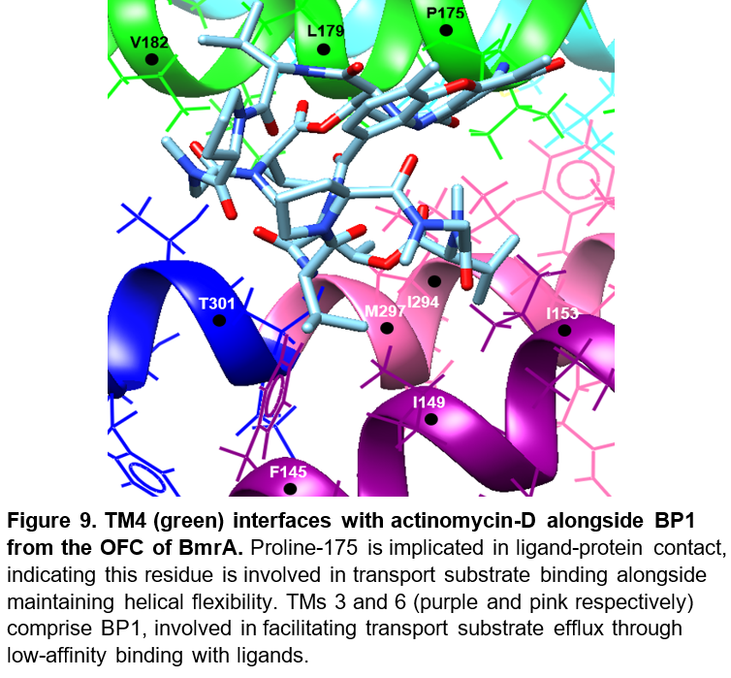Figure 9 exhibits another frequent high-affinity residue cluster from TM4, modelling interactions between OF-BmrA and actinomycin-D. In this case, the opposite face of the TM4 helix is implicated; this amino acid cluster is more frequently observed in outward-facing conformations, and hence mediates ligand binding to TM3 and TM6 from BP1 of the central binding cavity, which will be further explained shortly. Figure 9 therefore provides further evidence supporting TM4 as an intermediary facilitating polyspecific transport substrate entry into the central cavity, coupled to its initial role extracting hydrophobic ligands from the phospholipid bilayer alongside TM5 from the TM2-TM5’ interface.

As demonstrated in Figure 9 and our data-set more broadly, proline-175 mediates binding of transport substrates to the central cavity of BmrA.We speculate the electron-withdrawing nitrogen atom from the amino group of P175 creates a region of low electron density at the γ-carbon of the cyclopentyl ring, which enables proline-175 to form attractive electrostatic forces with lone electron pairs from oxygen atoms of the substrate, here a carbonyl group of actinomycin-D.Proline-175 also introduces conformational flexibility to TM4; participation of the nitrogen from the proline amino group in the cyclopentyl ring sidechain prevents this nitrogen from acting as a hydrogen bond donor at helical interfaces [56]. The absence of hydrogen bonds creates a weakness in this region of the helix, facilitating the structural motility of TM4 such that it can pivot 20° to bind transport ligands in the central cavity of BmrA [50,56]. This binary function of proline-175 suggests it is doubly critical to BmrA-mediated efflux, and therefore point mutagenesis of this residue into a helix-stabilising replacement such as alanine will provide further insight as to whether this residue is implicated in the onset of MDR for BmrA.

Residues proposed for mutagenesis thus far represent broad therapeutic targets – competitive inhibitors binding here are likely to inexplicitly impede efflux of every substrate. However, targeting non-substrate-specific residues will induce significant side-effects in patients, as they become unable to transport toxic compounds out of cells. It is therefore important to examine substrate-specific binding in the central transporter cavity, as modulating ligand-protein contact at substrate-specific residues may allow circumvention of resistance to just one therapeutic agent relevant to individual patients.

## **We speculate efflux of transport substrates from the central cavity proceeds through a two-step interaction involving two proximal ligand-binding sites:**

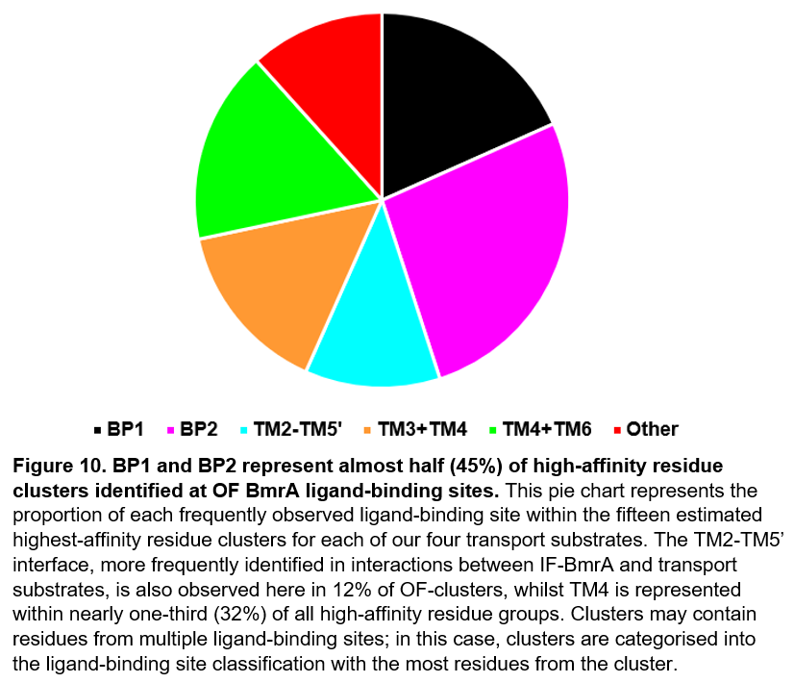Our computational data consistently implicates two interaction sites responsible for ligands binding OF-BmrA, as shown in Figure 10. BP1, which obligatorily contains TM1 and TM3, often accompanied by TM6, is highly prevalent within residue clusters identified during our analysis. Transport substrate binding is coupled with formation of the closed ATP-sandwich dimer, which induces a 20° pivot of TM4 about the central axis of the transporter. This substantial adjustment in TM4 tilt angle increases the spatial proximity of the flexible TM4 helix to BP1, enabling transport substrates to dock this binding site. Transport compounds can subsequently migrate to the opposite faces of TM3 and TM6 to interact with a second binding site, BP2, in the central cavity, from which molecules are exported. Like BP1, BP2 is frequently observed in the data-set, comprising 26.7% of identified high-affinity residue clusters as displayed in Figure 10.

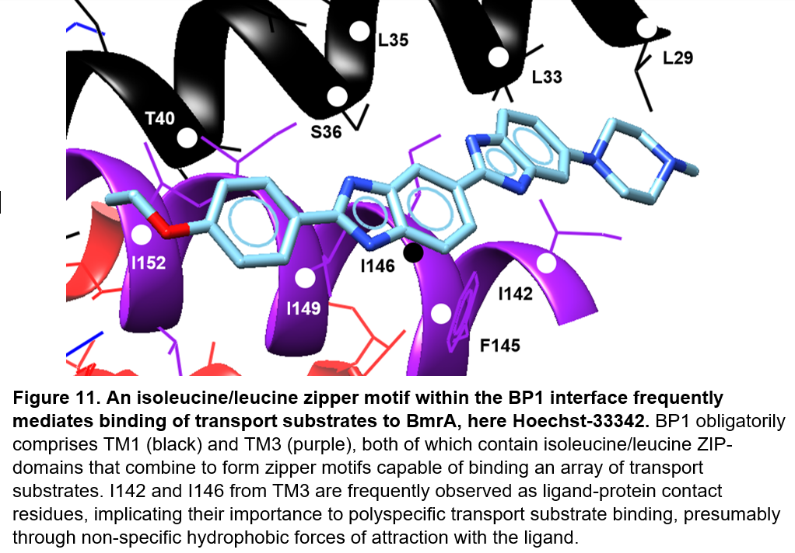Figure 11 demonstrates the interaction between Hoechst-33342 and BP1 from OF-BmrA. Here, we observe the nature of the ligand-transporter interface in BP1, which involves isoleucine-142 and isoleucine-146 from TM3, the two most frequent contact residues within our OF data-set. The prevalence of these amino acids within observed binding clusters strongly implicates their involvement in interfacing with transport substrates, through non-specific hydrophobic interactions that enhance protein-ligand stability.

Interestingly, both isoleucine-142 and isoleucine-146 are part of a TM3 leucine/isoleucine ZIP-domain that forms a complete zipper motif at the interface with TM4, containing L171, L176 and L179 residues, following dimerisation. Diverse studies investigating a range of ABC transporters have previously associated leucine/isoleucine zipper motifs with transport substrate binding; this further supports I142 and I146 as important ligand-contact residues, and provides supplementary evidence that TM4 mediates entry of transport substrates into BP1 [57]. The other helical prerequisite for BP1, TM1, also contains a leucine ZIP-domain, which encompasses residues implicated in protein-ligand contact including leucine-29 and leucine-33, as shown in Figure 11. Like TM4, this ZIP-domain from TM1 can form a complete zipper motif alongside TM3, further demonstrating the importance of isoleucine-142 and isoleucine-146 to the first step of broad transport substrate entry into the central binding cavity. Point mutation of these isoleucine residues into hydrophilic substitutes, for example arginine, and subsequent observation of the change in rate of drug efflux would therefore provide further insight into their relevance to MDR onset.

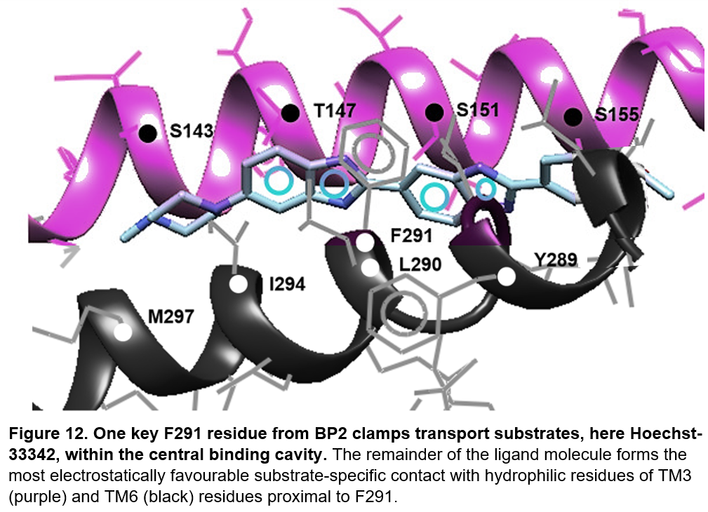The wide cleft above TM3 provides space for transport substrates to rotate to the opposite face of the TM3 helix. Here, exogenous ligands interact with a central binding site of the transporter cavity, BP2, which comprises TM6 in addition to this reverse face of the TM3 helix, as shown in Figure 12 with Hoechst-33342. Efflux of transport substrates proceeds from this central cavity – correspondingly, low-affinity residue clusters from BP2 are frequently observed in our OFC models.

It has previously been evidenced that protein-ligand binding in the central cavity is stabilised through π-π electrostatic forces of attraction with one key aromatic residue from TM6 of ABC transporters – in CmABCB1 this is tyrosine-358, and here for BmrA, phenylalanine-291 [52,58]. Whilst exogenous substrates obligatorily bind phenylalanine-291, transport ligands contact different TM6 residues proximal to F291 dependent on the nature of substrate. The exact position of this TM6-ligand contact is determined by the most electrostatically favourable interaction with hydrophilic polar-uncharged residues of TM3 - serine-143, threonine-147, serine-151, and serine-155. Hydrophilic amino acids therefore predominate along this face of TM3, providing alternative binding sites within BP2 for transport substrates.

Figure 13a presents experimental evidence supporting phenylalanine-291 as critical to transport substrate binding; an F291A mutation reduces the rate of Hoechst-33342 efflux relative to WT-BmrA. However, the reduction in the rate of both doxorubicin and Hoechst-33342 efflux relative to WT-BmrA is significantly less comprehensive following F291A than an E504A mutation in the NBDs of BmrA, previously well-characterised to inhibit ATP hydrolysis and thus prevent ligand extrusion [59]. This indicates F291 is not strictly obligate for transport substrate efflux, unlike E504, and other residues can substitute as the central aromatic clamp, for example tyrosine-289.

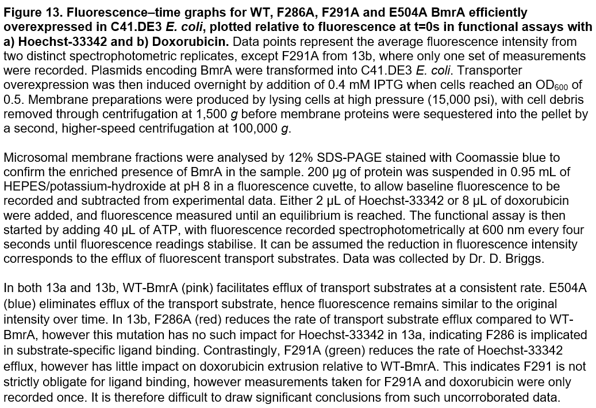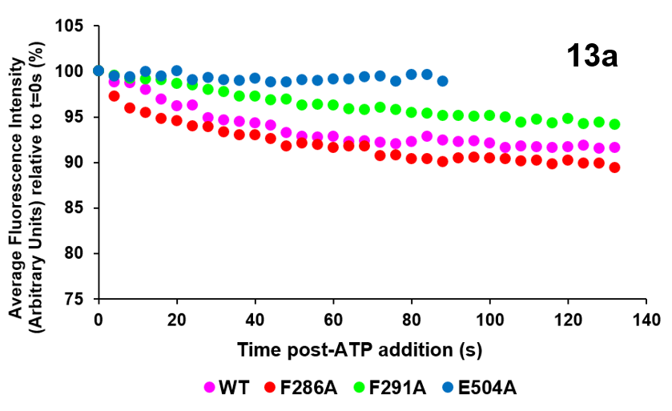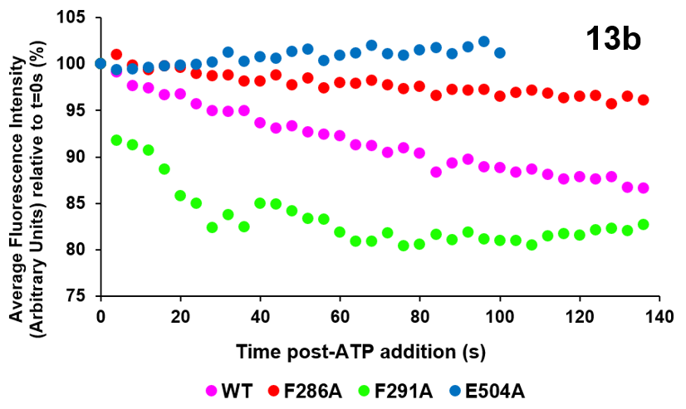Figure 13a also demonstrates an F286A mutation reduces the rate of Hoechst-33342 efflux compared to WT-BmrA, indicating phenylalanine-286 contributes to aromatic stacking π-π interactions with Hoechst-33342. However, F286A has little effect on the rate of doxorubicin efflux, as shown in Figure 13b, therefore this chemotherapy is likely to contact different binding residues from BP2. This suggestion is supported by our data-set, with F286 absent from doxorubicin-contact residue groups but present within several Hoechst-33342 binding clusters, demonstrating the substrate-specific nature of BP2 interaction.

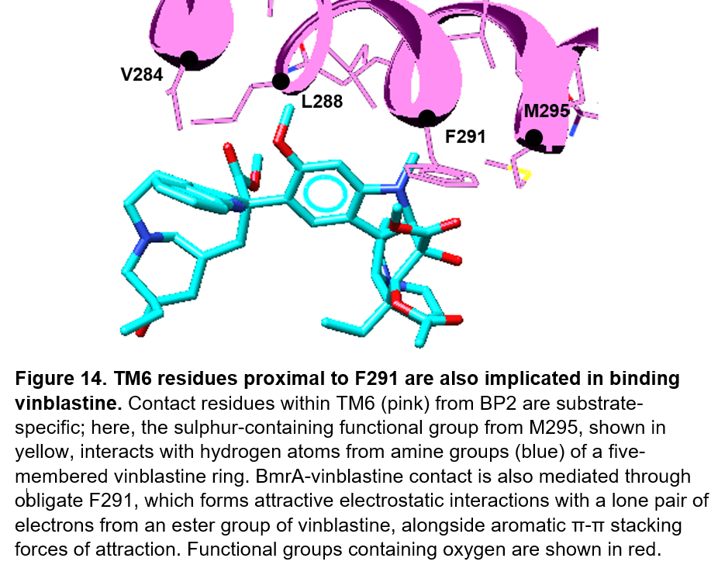Figure 14 demonstrates a methionine-295 residue from BP2 is implicated in binding vinblastine alongside the obligatory phenylalanine-291. The inductive electron-withdrawing nature of the phenylalanine-291 sidechain allows the slightly positively-charged α-carbon to form electrostatic forces of attraction with the lone pair of an oxygen atom from vinblastine [60]. This is a common mechanism of ligand-F291 interaction, allowing the aromatic ring of phenylalanine-291 to form perpendicular π-π stacking interactions with the transport substrate. In the case of vinblastine, slightly positively-charged hydrogen atoms from the amine groups of a five-membered ring can form additional electrostatic forces of attraction with a lone pair of electrons from the side-chain sulphur of methionine-295. Methionine-295 is also implicated at the interface between BmrA and actinomycin-D, however in the case of actinomycin-D, upstream glycine-298 and threonine-301 residues are also involved in the ligand-protein interaction. In this manner, BP2 facilitates polyspecific substrate efflux from the central transporter cavity, by providing alternative regions of potential ligand contact proximal to the obligatory phenylalanine-291.

Investigating the effect of F291A on the rate of both doxorubicin and Hoechst-33342 efflux has already provided further insight into the mechanism of transport substrates binding BmrA. It is therefore recommended we conduct similar experiments with additional transport ligands to confirm F291 is requisite for broad substrate binding. However, determining the identity of substrate-specific contact residues has higher clinical relevance – a secondary modulator binding implicated residues can inhibit the antitherapeutic efflux of a particular relevant therapy whilst the overall ability of the ABC transporter to resist exogenous toxins is retained.

We therefore conclude that whilst point mutagenesis of residues implicated in broad substrate binding is important in improving our understanding of MDR onset, ABC transporter research should focus on identifying substrate-specific ligand-protein contact residues to aid design of suitable inhibitors. Correspondingly, the rate of efflux of specific drugs should be measured both preceding and succeeding point mutation of implicated residues associated with binding individual transport substrates. For example, a decrease in the rate of vinblastine efflux following M295A mutation will confirm the importance of this residue in binding the chemotherapy. Modulators can subsequently be designed to bind this implicated methionine-295 residue, preventing the antitherapeutic efflux of vinblastine whilst retaining the ability of cells to extrude toxic compounds. Increasing the efficacy of vinblastine treatment will expedite patient remission from renal carcinoma. Successful isolation of residues essential for substrate-specific binding will therefore shape design of suitable modulators that inhibit residues implicated in efflux of individual therapies, thereby preventing patient deaths otherwise caused by resistance to medicinal compounds through a program of personalised treatment.

# **References:**

1. Prestinaci, F., Pezzotti, P., & Pantosti, A. (2015). Antimicrobial resistance: a global multifaceted phenomenon. *Pathogens and global health,* **109(7):** 309-318.
2. Duesberg, P., Stindl, R., & Hehlmann, R. (2000). Explaining the high mutation rates of cancer cells to drug and multidrug resistance by chromosome reassortments that are catalyzed by aneuploidy. *Proceedings of the National Academy of Sciences,* **97(26):** 14295-14300
3. Choi Y. & Yu A. (2014). ABC transporters in multidrug resistance and pharmacokinetics, and strategies for drug development. *Curr Pharm Des*, **20(5):**793-807.
4. Sharma, A. *et al.* (2019). Efflux pump inhibitors for bacterial pathogens: From bench to bedside. *The Indian journal of medical research,* **149(2):**129-145.
5. Juliano, R. L., & Ling, V. (1976). A surface glycoprotein modulating drug permeability in Chinese hamster ovary cell mutants. *Biochimica et Biophysica Acta (BBA)-Biomembranes*, **455(1):** 152-162.
6. Li, X., and Nikaido, H. (2009). Efflux-mediated drug resistance in bacteria: an update. *Drugs,* **69(12):** 1555-1623.
7. Blanco, P., Hernando-Amado, S., Reales-Calderon, J., Corona, F. *et al.* (2016). Bacterial Multidrug Efflux Pumps: Much More Than Antibiotic Resistance Determinants. *Microorganisms,* **4(1):**14.
8. Theodoulou, F. L., & Kerr, I. D. (2015). ABC transporter research: going strong 40 years on. *Biochemical Society transactions,* **43(5):** 1033–1040.
9. Xiong J., Feng J., Yuan D., Zhou J. & Miao W. (2015). Tracing the structural evolution of eukaryotic ATP binding cassette transporter superfamily. *Sci Rep,* **18(5):**16724.
10. Wilkens S. (2015). Structure and mechanism of ABC transporters. *F1000Prime Rep,* **3(7):**14.
11. Oswald, C., Holland, I. & Schmitt, L. (2006). The motor domains of ABC-transporters. *Naunyn Schmied Arch Pharmacol,* **372:** 385–399.
12. Lacabanne, D., Orelle, C., Lecoq, L., Kunert, B., Chuilon, C., Wiegand, T., Ravaud, S., Jault, J. M., Meier, B. & Böckmann, A. (2019). Flexible-to-rigid transition is central for substrate transport in the ABC transporter BmrA from *Bacillus subtilis.* *Communications biology,* **2:** 149.
13. Locher, K. (2016). Mechanistic diversity in ATP-binding cassette (ABC) transporters. *Nat Struct Mol Biol,* **23:** 487–493.
14. Ye J., Osborne A., Groll M. & Rapoport T. (2004). RecA-like motor ATPases--lessons from structures. *Biochimica et Biophysica Acta (BBA) – Bioenergetics,* **1659 (1):** 1–18.
15. Orelle, C., Dassa, E. & Davidson, A. (2008). Structure, Function, and Evolution of Bacterial ATP-Binding Cassette Systems. *Microbiology and Molecular Biology Reviews*, **72(2):** 317-364.
16. Szöllősi, D., Rose-Sperling, D., Hellmich, U. A., & Stockner, T. (2018). Comparison of mechanistic transport cycle models of ABC exporters. *Biochimica et Biophysica Acta (BBA)-Biomembranes*, **1860(4):** 818-832.
17. Srikant, S. & Gaudet, R. (2019). Mechanics and pharmacology of substrate selection and transport by eukaryotic ABC exporters. *Nature structural & molecular biology,* **26(9):** 792–801.
18. Hutter, C., Timachi, M., Hürlimann, L. *et al.* (2019). The extracellular gate shapes the energy profile of an ABC exporter. *Nature Communications,* **10:**2260.
19. Manolaridis, I., Jackson, S., Taylor, N. *et al.* (2018). Cryo-EM structures of a human ABCG2 mutant trapped in ATP-bound and substrate-bound states. *Nature,* **563:**426–430.
20. Kong, K. F., Schneper, L., & Mathee, K. (2010). Beta-lactam antibiotics: from antibiosis to resistance and bacteriology. *APMIS,* **118(1):**1–36.
21. Anes, J., McCusker, M. P., Fanning, S., & Martins, M. (2015). The ins and outs of RND efflux pumps in *Escherichia coli*. *Frontiers in microbiology,* **6:** 587.
22. Ziha-Zarifi, I., Llanes, C., Köhler, T., Pechere, J. C., & Plesiat, P. (1999). *In vivo* emergence of multidrug-resistant mutants of *Pseudomonas aeruginosa* overexpressing the active efflux system MexA-MexB-OprM. *Antimicrobial agents and chemotherapy*, **43(2):** 287–291.
23. Krügel H., Licht A., Biedermann G., Petzold A., Lassak J., Hupfer Y., Schlott B., Hertweck C., Platzer M., Brantl S. & Saluz H. (2010). Cervimycin-C resistance in *Bacillus subtilis* is due to a promoter up-mutation and increased mRNA stability of the constitutive ABC-transporter gene BmrA. *FEMS Microbiol Lett,***313(2):**155-63.
24. Steinfels, E., Orelle, C., Fantino, J., Dalmas, O., Rigaud, J.., Denizot, F., ... & Jault, J. M. (2004). Characterization of *YvcC* (BmrA), a multidrug ABC transporter constitutively expressed in *Bacillus subtilis.* *Biochemistry,* **43(23):** 7491-7502.
25. Sobell, H M. (1985). Actinomycin and DNA transcription. *Proceedings of the National Academy of Sciences of the United States of America,* **82(16):** 5328-31.
26. Hill, C., Cole, M., Errington, J., Malik, G., Boddy, A., & Veal, G. (2014). Characterisation of the clinical pharmacokinetics of actinomycin-D and the influence of ABCB1 pharmacogenetic variation on actinomycin-D disposition in children with cancer. *Clinical pharmacokinetics,* **53(8):** 741–751.
27. Calcagno, A. & Ambudkar, S. (2010). Molecular mechanisms of drug resistance in single-step and multi-step drug-selected cancer cells. *Methods in molecular biology,* **596:**77–93.
28. Taymaz-Nikerel, H., Karabekmez, M.E., Eraslan, S. *et al.* (2018). Doxorubicin induces an extensive transcriptional and metabolic rewiring in yeast cells. *Sci Rep*, **8:** 13672.
29. Walsh, N., Larkin, A., Kennedy, S., Connolly, L., Ballot, J., Ooi, W., Gullo, G., Crown, J., Clynes, M., & O'Driscoll, L. (2009). Expression of MDR markers ABCB1 (MDR-1/P-gp) and ABCC1 (MRP-1) in renal cell carcinoma. *BMC urology,* **9:**6.
30. Mignogna, C., Staibano, S., Altieri, V. *et al.* (2006). Prognostic significance of multidrug-resistance protein (MDR-1) in renal clear cell carcinomas: A five-year follow-up analysis. *BMC Cancer,* **6:** 293.
31. Loo, T., Bartlett M., Clarke D. (2003) Substrate-induced conformational changes in the transmembrane segments of human P-glycoprotein. Direct evidence for the substrate-induced fit mechanism for drug binding. *J Biol Chem,* **278(16):**13603-6.
32. Gottesman, M., Ambudkar, S., & Xia, D. (2009). Structure of a multidrug transporter. *Nature biotechnology,* **27(6):** 546–547.
33. Svirnovski A., Shman T., Serhiyenka T., Savitski V., Smolnikova V. & Fedasenka U. (2009). ABCB1 and ABCG2 proteins, their functional activity and gene expression in concert with drug sensitivity of leukemia cells. *Hematology,***14(4):**204-212
34. El-Awady, R., Saleh, E., Hashim, A., Soliman, N., Dallah, A., Elrasheed, A., & Elakraa, G. (2017). The Role of Eukaryotic and Prokaryotic ABC Transporter Family in Failure of Chemotherapy. *Frontiers in pharmacology*, **7:** 535.
35. The UniProt Consortium. (2012). Reorganizing the protein space at the Universal Protein Resource (UniProt). *Nucleic Acids Research,* **40:** D71–D75.
36. Schwede T., Kopp J., Guex N. & Peitsch M. (2003). SWISSMODEL: an automated protein homology-modeling server. *Nucleic Acids Research,* **31**:3381–3385
37. Bernstein F., Koetzle T., Williams G., *et al.* (1977). The protein data bank: a computer based archival file for macromolecular structures. *Journal of Molecular Biology*. **112(3):**535–542
38. Grosdidier, A., Zoete, V. & Michielin, O. (2011). SwissDock, a protein-small molecule docking web service based on EADock DSS. *Nucleic acids research,***39:** W270–W277.
39. Sterling, T. & Irwin, J. (2015). ZINC15–ligand discovery for everyone. *Journal of chemical information and modeling,* **55(11):** 2324-2337.
40. Goddard, T. (2018). UCSF ChimeraX: Meeting modern challenges in visualization and analysis. *Protein science: a publication of the Protein Society,* **27(1):** 14-25.
41. Chaptal, V. *et al.* (2021). Drug-bound and -free outward-facing structures of a multidrug ABC exporter point to a swing mechanism. *BioRxiv,* **10:**1101.
42. Szewczyk, P., Tao, H., McGrath, A., Villaluz, M., Rees, S., Lee, S., Doshi, R., Urbatsch, I., Zhang, Q., & Chang, G. (2015). Snapshots of ligand entry, malleable binding and induced helical movement in P-glycoprotein. *Acta crystallographica: biological crystallography,* **71(3):** 732–741.
43. Hofmann, S., Januliene, D., Mehdipour, A. *et al.* (2019). Conformation space of a heterodimeric ABC exporter under turnover conditions. *Nature,* **571:** 580–583.
44. Kodan, A., Yamaguchi, T., Nakatsu, T. *et al.* (2019). Inward- and outward-facing X-ray crystal structures of homodimeric P-glycoprotein CmABCB1. N*ature Communications,* **10:** 88.
45. Xia, D., Zhou, F. & Esser, L. (2019). Emerging consensus on the mechanism of polyspecific substrate recognition by the multidrug transporter P-glycoprotein. *Cancer Drug Resistance,* **2(3):** 471-489.
46. Ruiz, J. (2003). Mechanisms of resistance to quinolones: target alterations, decreased accumulation and DNA gyrase protection, *Journal of Antimicrobial Chemotherapy,* 51(5): 1109–1117.
47. Cherukuri, P., Songkiatisak, P., Ding, F., Jault, J., & Xu, X. (2020). Antibiotic Drug Nanocarriers for Probing of Multidrug ABC Membrane Transporter of *Bacillus subtilis.* *ACS omega,* **5(3):** 1625–1633.
48. Ramsbottom, K., Carr, D., Jones, A. & Rigden, D. (2018). Critical assessment of approaches for molecular docking to elucidate associations of HLA alleles with adverse drug reactions. *Molecular immunology,* **101:** 488-499.
49. Pantsar, T. & Poso, A. (2018). Binding Affinity via Docking: Fact and Fiction. *Molecules,* **23(8):** 1899.
50. Ward, A., Reyes, C., Yu, J., Roth, C. & Chang, G. (2007). Flexibility in the ABC transporter MsbA: Alternating access with a twist. *Proceedings of the National Academy of Sciences of the United States of America,* **104(48):** 19005–19010.
51. Kodan, A., Futamata, R., Kimura, Y., Kioka, N., Nakatsu, T., Kato, H., & Ueda, K. (2020). ABCB1/MDR1/P‐gp employs an ATP‐dependent twist‐and‐squeeze mechanism to export hydrophobic drugs. *FEBS letters.*
52. Kodan, A., Yamaguchi, T., Nakatsu, T., Sakiyama, K., Hipolito, C. J., Fujioka, A., ... & Kato, H. (2014). Structural basis for gating mechanisms of a eukaryotic P-glycoprotein homolog. *Proceedings of the National Academy of Sciences,* **111(11):** 4049-4054.
53. Koh, A., Gibbon, M., Van der Kamp, M., Pudney, C., & Gebhard, S. (2020). Control of histidine kinase conformation by an ABC-transporter facilitates need-based activation of antibiotic resistance. *bioRxiv.* **10:**1101.
54. Ballesteros, J. A., Deupi, X., Olivella, M., Haaksma, E. E., & Pardo, L. (2000). Serine and threonine residues bend α-helices in the χ1= g− conformation. *Biophysical journal,* **79(5):** 2754-2760.
55. Blanco, S., Sanz, M. E., López, J. C., & Alonso, J. L. (2007). Revealing the multiple structures of serine. *Proceedings of the National Academy of Sciences,* **104(51):** 20183-20188.
56. Richardson, J. S. (1981). The anatomy and taxonomy of protein structure. *Advances in protein chemistry*, **34:** 167-339.
57. Trakhanov, S., Vyas, N., Luecke, H., Kristensen D., Ma J. & Quiocho F. (2005). Ligand-free and -bound structures of the binding protein (LivJ) of the *Escherichia coli* ABC leucine/isoleucine/valine transport system: trajectory and dynamics of the interdomain rotation and ligand specificity. *Biochemistry,* **44(17):**6597-608
58. Gose, T., Shafi, T., Fukuda, Y., Das, S., Wang, Y., Allcock, A., ... & Schuetz, J. D. (2020). ABCG2 requires a single aromatic amino acid to “clamp” substrates and inhibitors into the binding pocket. *The FASEB Journal,* **34(4):** 4890-4903.
59. Orelle, C., Dalmas, O., Gros, P., Di Pietro, A., & Jault, J. M. (2003). The conserved glutamate residue adjacent to the Walker-B motif is the catalytic base for ATP hydrolysis in the ATP-binding cassette transporter BmrA. *Journal of Biological Chemistry,* **278(47):** 47002-47008.
60. Liyanage, W., & Nilsson, B. (2016). Substituent effects on the self-assembly/co-assembly and hydrogelation of phenylalanine derivatives. *Langmuir,* **32(3):** 787-799.

**Appendices:**

[Appendix 1 - Contact Residues between our structural models and four selected substrates - pdf](https://uniofnottm-my.sharepoint.com/:b:/g/personal/stymwg_nottingham_ac_uk/EUfVuFVLP4BPhcX0JR3jUOgBBB-jkCVovgEr6hZg-I1U3A?e=KE0gAR)

[Appendix 2 - Experimental Data investigating Hoechst-33342 and Doxorubicin efflux from WT, F286A, F291A and E504A BmrA - pdf](https://uniofnottm-my.sharepoint.com/:b:/g/personal/stymwg_nottingham_ac_uk/ESVlksIYbXBJukM-C0Kmn1EB-Y9ZIrqnNlsmdsfUeXwihA?e=WEpRns)